**Computer Science & Software Engineering**

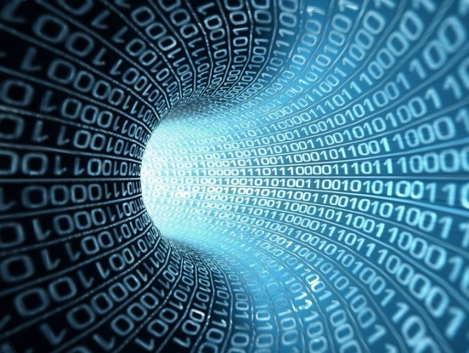**1.2.1A Binary to Decimal Conversion**

Name: __________________

Date: _______ Period _____

Technology Education Dept

Pittsford Central Schools

**Procedure**

To convert a binary number into a decimal number use the place value method.

Example: Convert the binary number 10102 into decimal 1010.

128 64 32 16 8 4 2 1 Place value

1 0 1 02  Binary

8+0+2+0 = 1010

**Convert the following binary numbers to decimal:**

1. 00010012 = _______________

2. 110112  = _______________

3. 1010112  = _______________

4. 001110 2 = _______________

5. 111000 2 = _______________

6. 010101 2 = _______________

7. 110011 2 = _______________

8. 000110 2 = _______________

9. 111001 2 = _______________

10. 0000112  = _______________